The Correlation Heatmap And Its Interpretion

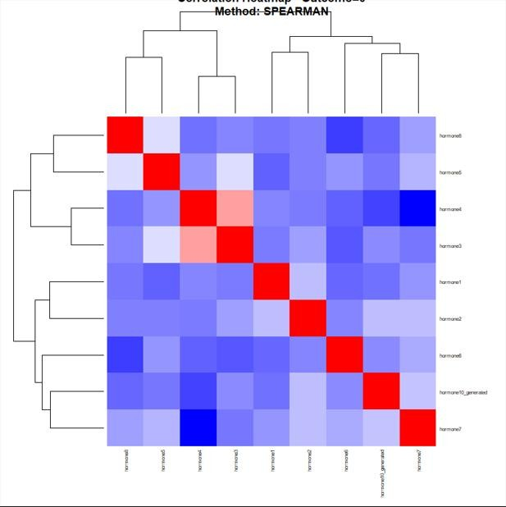

Figure 1: The correlation heat map of group 0

The correlation heat map for Group 0 demonstrates the pattern of relationships among the hormonal variables within the dataset. Areas shaded in red indicate positive correlations, meaning that the concentrations of certain hormones tend to increase simultaneously, while blue regions represent negative correlations, where an increase in one hormone is associated with a decrease in another. The predominance of lighter shades across several variables suggests that many of the associations are weak to moderate rather than extremely strong. This pattern indicates that the hormonal system in Group 0 operates through interconnected but balanced physiological mechanisms, where some hormones exhibit coordinated activity while others function independently.

Statistically, the heat map implies the existence of meaningful inter-variable associations within Group 0, although the relationships are not uniformly strong across all hormones. The presence of moderate positive correlations suggests possible shared biological pathways or regulatory feedback mechanisms among certain hormones. In contrast, the weaker and negative associations indicate variability in endocrine responses and possible counter-regulatory effects between some variables. The absence of excessively strong correlations also suggests a lower likelihood of multicollinearity among the variables, which is important for ensuring stability and reliability in subsequent multivariate statistical analyses such as regression or factor analysis.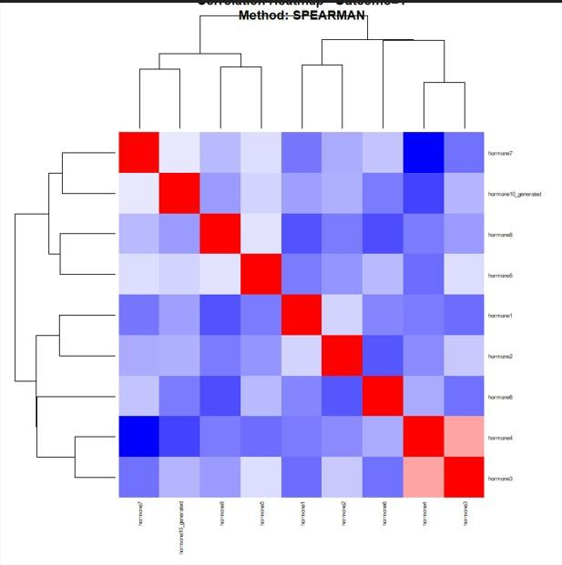

Figure 2: Correlation heat map of group 1.

The correlation heat map for Group 1 reveals a more heterogeneous hormonal interaction pattern compared with Group 0. A larger proportion of blue-shaded regions indicates the presence of several inverse relationships among the hormones, suggesting that increases in some hormones are associated with reductions in others. The clustering of both positive and negative associations demonstrates that hormonal activity in this group is more varied and less synchronized. This distribution reflects a more complex endocrine interaction network, where hormones may exert opposing physiological effects or respond differently under the conditions represented in Group 1.

From a statistical perspective, the increased number of negative correlations suggests stronger antagonistic interactions among variables in Group 1. Such a pattern may indicate greater variability in hormonal regulation and a more dynamic physiological response system. The mixed correlation structure further implies that the variables do not move uniformly in the same direction, which may affect predictive modeling and interpretation of hormonal interactions. Additionally, the diversity of correlations observed in this group suggests the potential presence of subgroup-specific biological mechanisms or external influencing factors, thereby emphasizing the importance of considering group differences in inferential and comparative statistical analyses.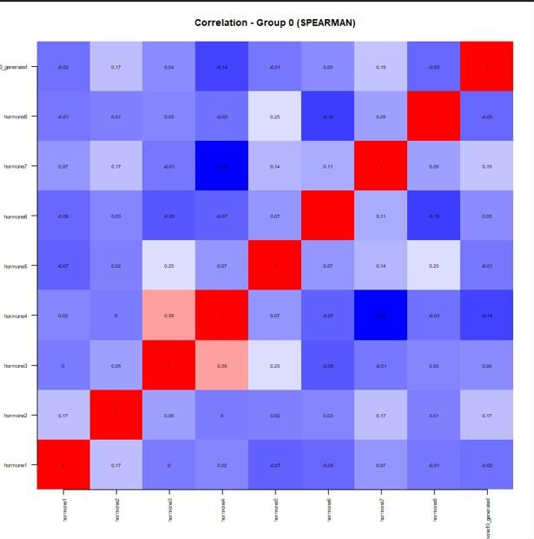

Figure 3: Correlation simple group 0(SPEARSMAN )

The Spearman correlation matrix for Group 0 illustrates the monotonic relationships among the hormonal variables using rank-based correlation measures. The matrix shows predominantly weak-to-moderate associations, indicating that while some hormones display coordinated behavior, the overall interaction pattern remains relatively balanced and distributed. Positive correlations reflect hormones that tend to vary in the same direction, whereas negative correlations indicate inverse hormonal responses. The overall structure suggests that the endocrine system in Group 0 is regulated through multiple interacting pathways rather than being dominated by a single hormonal mechanism.

Statistically, the use of Spearman correlation is appropriate because it measures non-parametric relationships and is less sensitive to non-normality and outliers within the dataset. The moderate coefficients observed imply that the variables share some degree of association without demonstrating excessively strong dependence. This indicates that the hormonal variables retain distinct contributions within the dataset while still exhibiting biologically meaningful relationships. Furthermore, the mixed pattern of positive and negative correlations supports the interpretation that endocrine regulation in Group 0 involves both synergistic and counter-regulatory processes, which may be relevant in explaining physiological variability among subjects.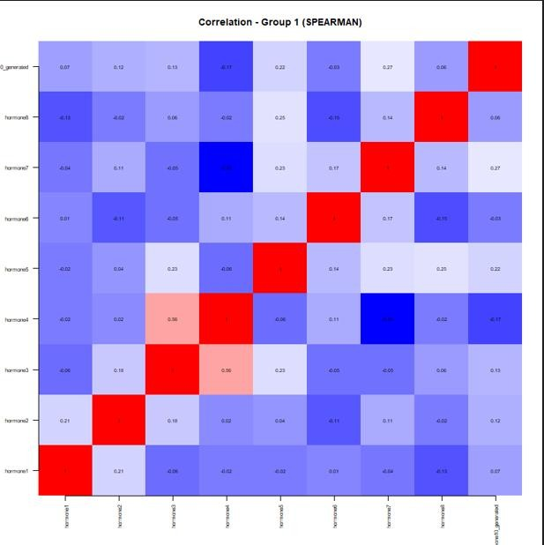

Figure 4: Correlation simple group 1(SPEARSMAN )

The Spearman correlation matrix for Group 1 presents a complex network of hormonal interactions characterized mainly by weak-to-moderate associations. Similar to Group 0, both positive and negative correlations are evident; however, the inverse relationships appear slightly more pronounced. This indicates that several hormones may respond differently or oppositely under the physiological conditions represented in this group. The interaction pattern reflects a multifaceted hormonal regulatory system in which multiple endocrine pathways operate simultaneously and influence one another to varying degrees.

The statistical implication of this matrix is that Group 1 exhibits substantial variability in hormonal relationships, suggesting a more diverse endocrine response pattern. The predominance of weak-to-moderate coefficients indicates that no single hormone overwhelmingly determines the behavior of the others, thereby reducing the risk of redundancy among variables. Additionally, the presence of more negative associations may signify stronger compensatory or inhibitory mechanisms within the hormonal network. Since Spearman correlation evaluates ranked relationships, these findings also suggest that the associations are consistent in direction even if they are not strictly linear, making the analysis suitable for capturing complex biological interactions within the dataset..

